**2019 For Good Foundation Volunteer Awards**

Applications close 16th of August 2019

**Guidelines**

Here at the For Good Foundation we want to give back to those who give. To do that we are launching our inaugural For Good Foundation Volunteer Awards, recognising significant volunteer services and contributions within the South Australian volunteer sector, specifically for those volunteers who deliver support services in the area of domestic abuse and family violence prevention, and after care support.

**To be considered for an award, nominees must;**

* Currently be a volunteer.
* Have consistently volunteered for their cause for at least six months.
* Be affiliated with volunteer work that aligns to the values of the For Good Foundation.
* Not receive a wage or salary for the work undertaken.
* Be able to provide at least 2 reference for their work. Referees must not be related to the nominee.
* Be an Australian Citizen or permanent resident.
* Be willing to provide or consent to a criminal history check.

There are many, fantastic and committed volunteers across our State, that give their time and energy to help others, and for this reason we are providing several awards across five categories.

|  |  |  |  |  |
| --- | --- | --- | --- | --- |
| **Youth** | **Equity** | **Change** | **Support** | **Senior** |
| Under 21 years old  Demonstrated  commitment to their chosen cause  Influential advocate  Leadership potential  Willingness to learn | 21 years old or older  Demonstrate commitment to a cause that supports equality of opportunity to individuals from diverse background.  Proven influence in equality outcomes. | 21 years old or older  Demonstrated commitment to a cause that promotes and facilitates change, ultimately aiming to improve the lives of others.  Promotes change and manages the change process | 21 years old or older  Demonstrated commitment to a support role for people in need of assistance and support.  Provision of support services | 60 years old or older  Demonstrated commitment to their chosen cause  Broad experience and a volunteering capacity  Mentoring of other volunteers |

**Who Can Nominate?**

Individuals or Groups involved with or having received support from an outstanding volunteer can nominate them to receive $1,000 and an International Volunteer Day certificate of appreciation.

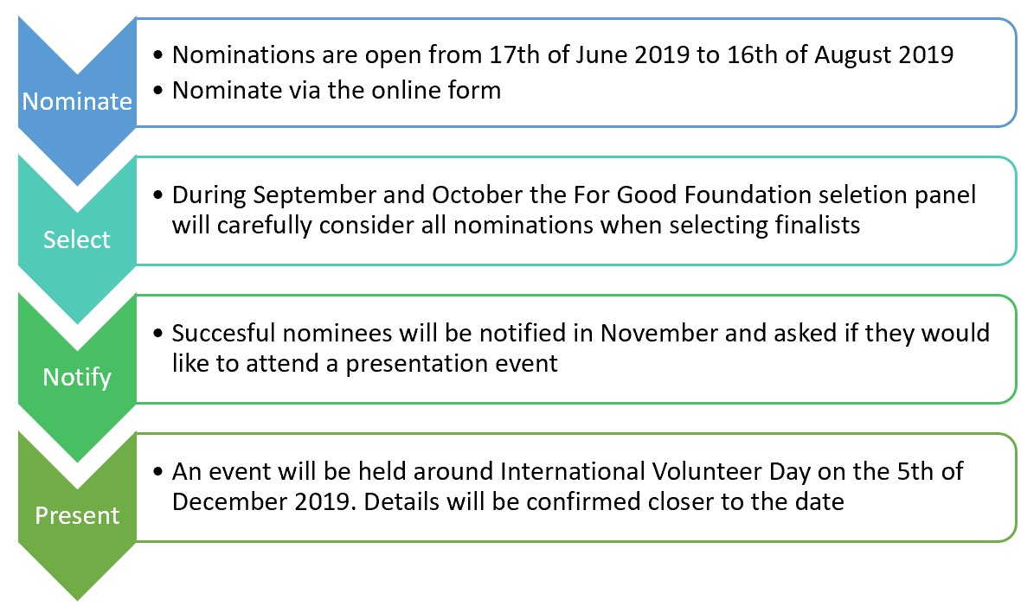

**Selection Criteria**

The For Good Foundation volunteer awards are open to outstanding volunteers who have contributed to the lives of South Australians affected by domestic abuse and family violence.

The For Good Foundation will consider all nominations who have;

* made significant contribution to and individual or community within South Australia
* provided ongoing commitment and dedication to volunteering
* demonstrated leadership in their volunteer role
* promoted volunteering within the community
* significant effort in fundraising for a cause
* going above and beyond what is expected of them in their volunteering role

Please note that one off financial donation from an individual or organisation will not be considered for an award.

**Nomination**

Once you have read the eligibility criteria and guidelines, you can nominate via the online **nomination form** <https://hfgf.org.au/nomination-form/>

If you are unable to submit your nomination online, you can download a copy of the nomination form and email a completed version to **crew@hfgf.org.au**

For nominations to be eligible, nominations must be received by 16th of August 2019.

**Recognition of winners**

Successful nominees will be invited to attend an event on [date here] where award certificates will be presented. If nominees are unable to attend, or would prefer to receive their award in confidence, this can be arranged.